Asia-China-Coin-Wang Mang-H 9.12 R3

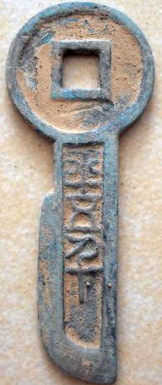 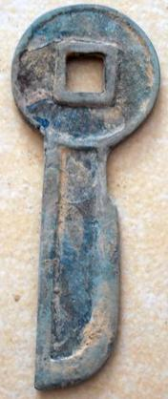

Height 6.9 cm.